# CA FireHero

|  |  |
| --- | --- |
| Student Name | Marek Martinak |
| Student ID | D00250465 |
| Class Group | AVR2 |

## **Overview**

The game is currently titled FireHero, which may change as the game develops. You want to try to save a child or a person in the house. You want to put out a fire that will spread throughout the house. Destroy and search for things in the fire. My idea for a game is about firefighters. I want the players to get to know in a fun way what firefighters do, what their duties are, and what it looks like. The story is about a man who wants to become a fireman, and when the opportunity presents itself, he takes it and never lets it go.

Possible Objectives:

Getting into the house

Put out the fire

Rescuing a person from a burning house

Use a ladder

Calm the hurt animal

Turn off the alarm

Characters:

Player:

The player must perform the tasks that his teammate gives him. He wants to become a firefighter and when fate gives him the opportunity to become one, he doesn't hesitate and goes for it.

Firefighter:

A worker who assigns tasks to the player. He gives him advice on how to complete the tasks and what to do next. He's been in the job a long time and sees the potential in the player to be one of the best firefighters on the planet.

Enemies:  
 Natural things that could hurt you in real life. For example, things   
 falling on your head, fire or smoke that can suffocate you.

Genre: VR Firefighter Simulator game.

## **Game Design**

As I mentioned, the game is about Firefighter. I was mainly inspired by a profession I've seen in person and thought it might be fun in a game. This means that I mainly want the player to be able to take a fire extinguisher and put out the fire. Another thing is the axe, which will be used to destroy doors and other barricades that prevent the player from completing the task. The player will have a time limit in some levels, which he will have to fulfill otherwise he will fail. Fire can burn and injure you, so you'll have to be careful what you do.

The game should be fun and not necessarily hard. One of the things that will bother the player is the time limit, which will force him to save everyone. If he does what is asked of him, he can do whatever he wants in the level.

If the player completes a level, he will be able to move on to the next one. It will be a series of levels in which the player will have to complete a task. Gradually, new tools will be shown to the player. If the player dies, he will be able to repeat the level.

The game will be played primarily on a VR headset. It will be controlled using controllers. The player will move around using the buttons. The buttons are used for teleportation and for interacting with items and with

Color Palette

|  |  |  |
| --- | --- | --- |
| Fire | Smoke | Liquid |

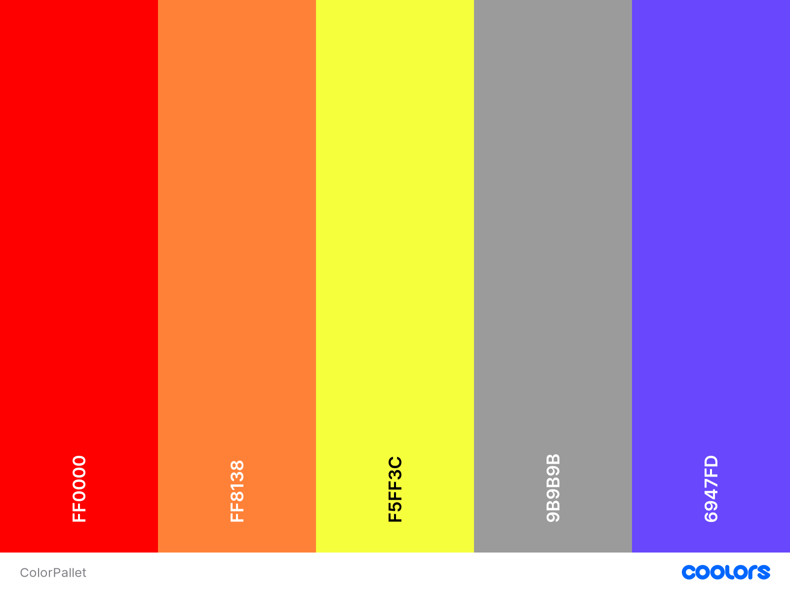

Moodboard

Graphics

The graphics would be similar to a Job Simulator game. Not too realistic. It would be colorful and bright. 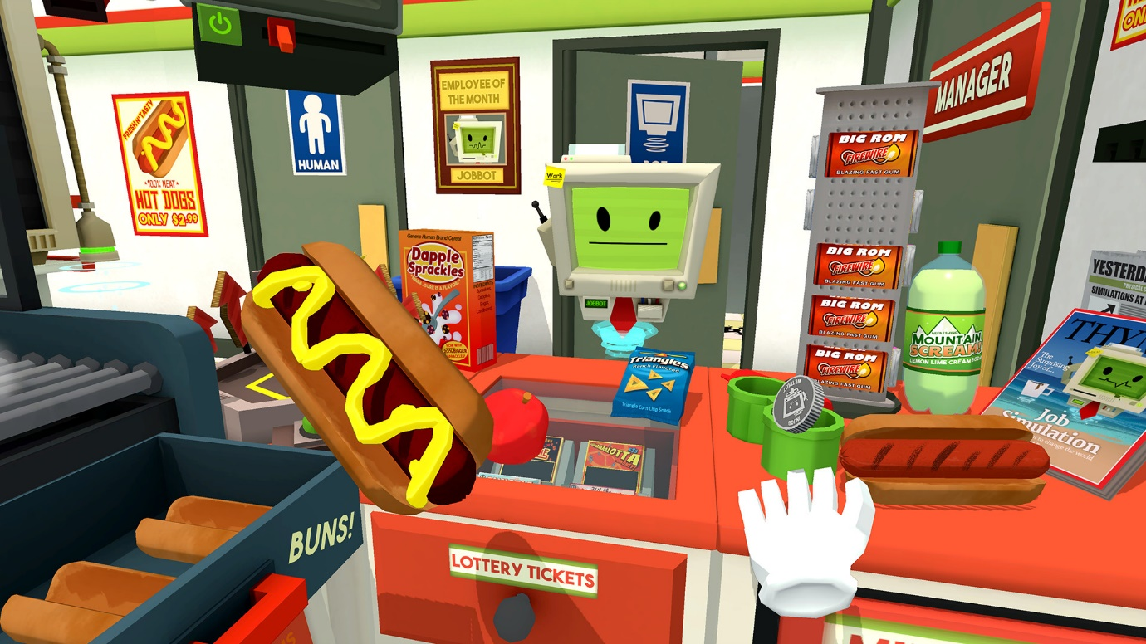

I'd like to make a nice visual fire. Similar to the one in the Little Inferno, where the nature of the fire was pretty important.

Sound

## The sound design would be primarily concerned with sound effects. It will depend on the level and the environment the player is in. The level will depend mainly on the sound effects, which will give the necessary atmosphere.

|  |  |
| --- | --- |
| Diegetic sound | |
| Fire Extinguisher | The sound of a chemical extinguishing a fire. |
| Axe | The sound of an axe destroying things. |
| Baby | Child screaming for help |
| Fire | The sound of fire slowly destroying the building. |
| Fire Alarm | An annoying alarm that you want to turn off as soon as possible. |

|  |  |
| --- | --- |
| Non-Diegetic sound | |
| Win | A cheerful sound that signifies success |
| Loose | The tragic sound that signifies failure |
| Menu | Just clicking |

## Level Design

The first level will take place in a small village where a fire breaks out in a small house. A small screaming child can be heard from outside and the main character of this video game doesn't hesitate for very long. He takes a fire extinguisher and an axe and goes into the house. On his way, he has to watch out for fire which can burn and even kill him, or smoke that can suffocate him. Obstacles that the player will have to watch out for are for example a collapsing house and its remains. The player will have to try and find the child using sound. After the player picks up the child, a fire truck arrives. The player must take the child to the fire truck. Thanks to this, he will complete the first level.

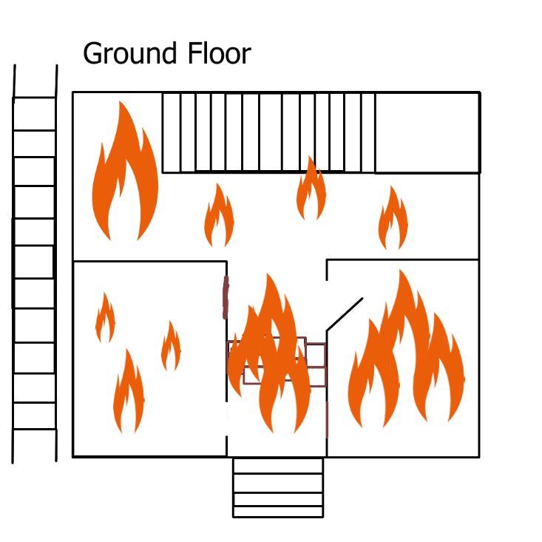

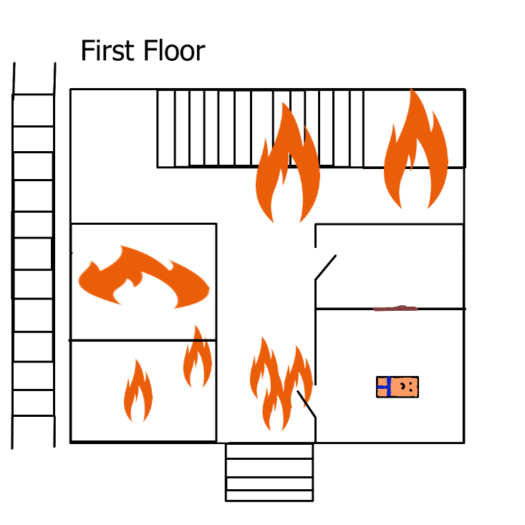

Fire – Can be extinguished with a fire extinguisher

Ladder - Take the ladder and put it in front of the window

Brown – Things that can be destroyed with axe

## User Interface

In the menu there should be game settings, start and exit the game. Gradually as the player continues in the game, the option to play previous levels will open. The HUD menu will be very elegant and nice. The font is sleek and the menu buttons are white. If the player fails, the sound will gradually increase. For the first level, it will be a child screaming in flames. But if he succeeds he will hear the sound of people applauding him for helping them.

The menu will display the basic controls. However, as the game progresses, new controls will appear that allow the player to use the tools. Instructions for using the tool will be given on the adjacent paper. A health bar will appear on the player's left hand, as well as a clock to show the player how much time they have left. The health indicator will look like a green tube that will gradually shrink as the player's health decreases. I took inspiration from the game Death Space. The player will be able to put some tools around his waist, which will be his inventory system.

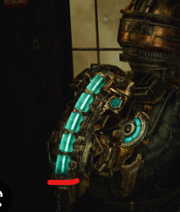

|  |  |
| --- | --- |
| Assets | |
| Environment | ProBuilder/[Kenney asset](https://www.kenney.nl/assets?q=3d) – Depends on the situation, but I would like to use mostly Kenney asset |
| Sound effect and music | [Freesound](https://freesound.org/) – Website with good sound effects. The condition is that you have to create an account, but the site never asks you to do anything else. |
| Menu | [Figma](https://www.figma.com/) - A website I've heard is good for design, so I'd like to try it out. |
| Tools | Blender/ProBuilder/Online - It depends on the tool, but I would like to try to create an item and use it in Unity. I don't know yet how hard it is to make it work. |

## Unique Mechanic For Block Test & Feedback

For the block test, I mainly wanted to create a fire extinguisher that would allow me to put out the fire. I didn't know how, but I knew it was pretty important to my game. I was introduced to particle system and had a rough idea in my head of how it might work. So I installed a fire extinguisher asset, but it was falling through the floor. Didn't come happening so I created my own in probuilder.

I gave it the XR Grab Interactable code so the player could pick it up. Next, I needed particles. Next I needed particles. For those, I had the problem that the collisions weren't working. The OnColliosionEnter function did not work. So I searched the internet and found that I have to use OnParticleCollision. I assigned that when the particle touches the object with the fire tag, it disappears.

It still didn't work though. I found that there was no problem in my code. I watched a [video](https://www.youtube.com/watch?v=Eua7G7Vct0A&t=306s&ab_channel=TheRealTimeEssentials) that talked about the basics of particles and found that I had to turn on the Collision section that I didn't know about.

I set it up and then set about adjusting the shape and colour of the particles.

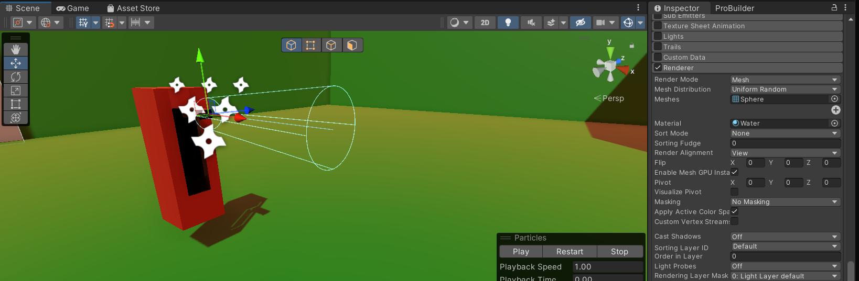

After all these modifications, my code finally worked. Still, I wanted the fire to have some health so that it wouldn't disappear right away, so I created another part of my program. I also wanted it to get progressively smaller as it got smaller, so [I found a way to do that](https://forum.unity.com/threads/how-to-change-scale-of-a-gameobject-in-run-time.109705/).

But the thing is, I'm not sure it's working. Especially with the health, I'm not sure they work. The fire changes size, but for some reason, it changes height upwards. It's something I'll have to work on and improve.

For a given test level, I created a block to represent fire. I gave it an orange color and a fire tag. If the particles from the fire extinguisher touch the block, they disappear after a while.

I added sound and light to some fire to add at least some experience. I placed the light and sound under the fire so that when it disappeared, the light and sound would disappear.

Then I created a child that disappears when placed on the mattress, and that completes the level. For the baby, I downloaded the crying sound and put it in the game.

I put on the fire extinguisher part of the code I learned from Naoise, where in order to use the fire extinguisher he has to use his left hand.

I quickly created a map for people to try out.

**First Block Testing**

I asked these 5 questions that I got from Naoise

* What was your **favorite moment**?
* What was your **least** favorite moment?
* When did you feel the most **clever**?
* Was there anything you wanted to do that the game **wouldn't let you do**?
* If you had a **magic wand** and could change any aspect of the game or your experience, what would it be?

I asked these questions and tried to take something from it.

1. Subject   
   Name: Sean

Profession: A student from DKIT, he is in his 3rd year of Augmented and Virtual Reality.

|  |  |
| --- | --- |
| 1. | He liked fire extinguisher |
| 2. | For him, the controls were really bad (It took him while to understand how to move) |
| 3. | When he could have put out the fire |
| 4. | He saw ladder which he couldn’t use |
| 5. | He would do better controls or at least to show them |

1. Subject   
   Name: Josef, 21 years old

Profession: A student from DKIT, he is in his 2rd year of Software development

|  |  |
| --- | --- |
| 1. | He liked throwing the kid |
| 2. | He didn’t like controls |
| 3. | When he found out how to use fire extinguisher |
| 4. | Movement with joystick |
| 5. | Better graphic (He didn't know the orange boxes were fire) |

1. Subject

Name: Ryan, 23 years old

Profession: A student from DKIT, he is in his 2rd year of Computer Science

|  |  |
| --- | --- |
| 1. | The beginning (He enjoyed to look around) |
| 2. | He didn’t know what to do first |
| 3. | When he used the fire extinguisher |
| 4. | Go in the house |
| 5. | Better design (More interactable things, more fire, subtitles, voice over or checkpoints what to do) |

For the next test I decided to make a slightly better house and a better environment. I got an email from which I understood to do more testing in 3D on the computer. Maybe I misunderstood something, but I decided to do it since I don't have a VR headset and a computer that could handle it.

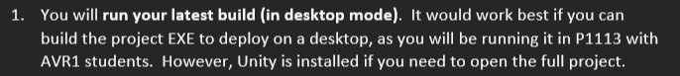

I lowered the light and added an asset to create a better environment.

I've found that some things are easier to program in VR than in 3D, or vice versa. For example, in VR it's easy to make something grab, just a few clicks and you're done. I found a [youtube tutorial](https://www.youtube.com/watch?v=zgCV26yFAiU&ab_channel=Rytech) in 3D that helped me with this. I had to create an empty object that serves as a thing to help me pick up objects. Then all I had to do was write the same code as in the video and set up Layer Pickup.

I accidentally found a way to hold down the button while coding and it does something, depending on how it's set up. In my case, I set tab and f . The tab button is the explanation of what to do, and the f button is the fire extinguisher.

**Second Block Testing**

1. Subject

Name: Jiri

Profession: A student from DKIT, he is in his 1rd year of Augmented and Virtual Reality.

|  |  |
| --- | --- |
| 1. | He liked fire extinguisher |
| 2. | Walking up stairs in 3D is difficult |
| 3. | When he found out the fire was the orange block |
| 4. | Didn’t know |
| 5. | To make it more harder (Timer for example) |

1. Subject

Name: Melvin

Profession: A student from DKIT, he is in his 1rd year of Augmented and Virtual Reality.

|  |  |
| --- | --- |
| 1. | Fire extinguisher |
| 2. | Flames, basic graphic |
| 3. | Door (He can do something with them) |
| 4. | Throwing the baby (It wasn’t button for it) |
| 5. | Better Fire |

1. Subject

Name: Ida Tellonova

Profession: A student from DKIT, she is in his 1rd year of Augmented and Virtual Reality.

|  |  |
| --- | --- |
| 1. | Throwing baby |
| 2. | Stairs |
| 3. | Using fire extinguisher |
| 4. | Ladder |
| 5. | She didn’t know |

After these tests, I programmed a basic axe into VR that can destroy blocks with the axe tag.

Also what annoyed me and people mentioned it was the way a fire extinguisher or an axe is gripped in the hand. So I found a [youtube tutorial](https://www.youtube.com/watch?v=4N0AZ3NZimo&ab_channel=FistFullofShrimp) on how to set it up better.

After testing, I found a few bugs and things I would like to fix. Mainly I would like to improve the graphics, controls and program the ladder into the alpha. I want to fix the bugs people have told me and then test it.

GitHub – use 3D branch to get the right version - <https://github.com/Aang1214/FinalVR/tree/3D>

## Roadmap

1. Week

We had an introduction for the VR and for GitHub.

1. Week

Try to find way how to fix VR

Actual:

We had trouble to find out how to move with hands and how to move overall

1. Week

We finally found out how to move in VR

1. Week

Start with game design document

Introduction to particles and codes for them.

1. Week

User testing and uploading the first part of the CA

1. Week

Improve the fire extinguisher

1. Week

Program ladder

1. Week

Better graphics

1. Week

Make an NPC

1. Week

Finishing for alpha

1. Week

Make a cutscene for beta

1. Week

Finishing for beta

1. Week

Preparing for the Interview

## Bibliography

Particles <https://www.youtube.com/watch?v=Eua7G7Vct0A&t=306s&ab_channel=TheRealTimeEssentials>

Scale  
<https://forum.unity.com/threads/how-to-change-scale-of-a-gameobject-in-run-time.109705/>

PickUp Item  
<https://www.youtube.com/watch?v=zgCV26yFAiU&ab_channel=Rytech>

Grab Interactables basics <https://www.youtube.com/watch?v=4N0AZ3NZimo&ab_channel=FistFullofShrimp>